

***No. 1***

**Capaneus**

Capaneus is the son of Hipponous. You can find him in the seventh circle of Hell, sinful for being violent against God. His soul is tormented with fire as he lies on burning sand. Capaneus is known for his strength and is often referred to as a warrior.

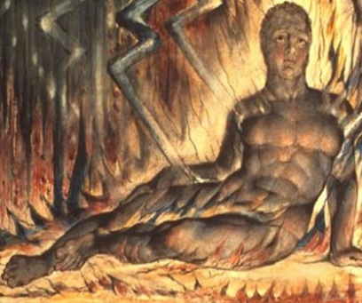

*Warrior King- Blasphemer*

His punishment is described in Dante’s Inferno: *“O’er all the sand-waste, with a gradual fall, Were raining down dilated flakes of fire…”* (Alighieri, 54).



***No. 2***

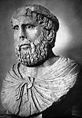



**Pier Delle Vigne**





**Pier Delle Vigne was a poet and wrote various sonnets. He was a chief adviser; he made the final decision for Emperor Frederick II. Pier was accused of violating majesty and later committed suicide after being imprisoned. Vigna means “vineyard” making it perfect to have him as one of the suicide trees in Dante’s Inferno.**

***Pier said in Dante’s Inferno: “I am the one who both keys had in keeping of Frederick’s heart and turned them to and fro…” (Alighieri, 51).***

*Poet- Suicide*

***No. 4***

Dejanira means “man-destroyer.” She was Hercale’s second wife and also the daughter of Althaea and Oeneus.

Dejanira

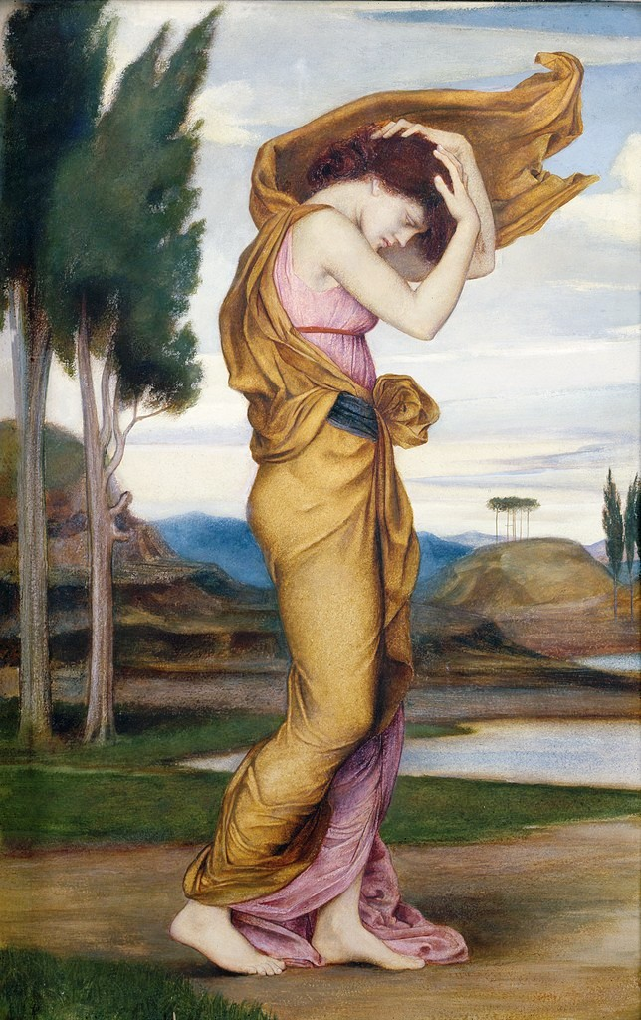

Geryon

*Monster- Fraud*



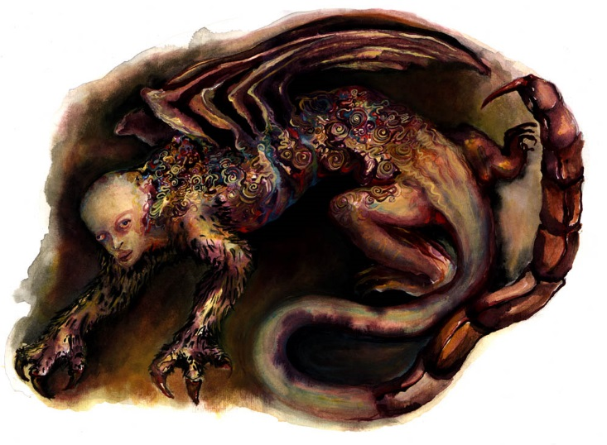

**“Behold the monster with the pointed tail” (Alighieri, 64).**

Geryon represents fraud. His body consists of an honest-looking man’s head followed by a snake-like body and a scorpion stinger for a tail. He has two paws and is found between the seventh and eighth circle.

***No. 3***

Brunetto Latini

***No. 6***

Chiron is a centaur. He is half horse half human. Chiron is the son of Cronus and Philyra. He is noted for his youth-nurturing nature. Centaurs are known for being wild.

Chiron

***No. 5***